**For more information, contact:**

Dan Danford, 262-636-7359

[dan.danford@caseih.com](mailto:dan.danford@caseih.com)

Julie Caan, 920-912-3445

jcaan@bader-rutter.com

**New Case IH Nutri-Tiller 955 Strip-till Applicator**

**Delivers One-pass Seedbed Efficiency**

*New tool supports growing trend toward more efficient crop production*

RACINE, Wis. (Aug. 24, 2016)

With strip-till continuing to expand across new acres, Case IH designed the new Nutri-Tiller 955 strip-till applicator to help producers better manage nutrients and conserve soil.

“The Nutri-Tiller 955 delivers the agronomic advantages of conventional tillage, along with the economic and conservation benefits of no-till,” said Dave Long, Case IH seeding equipment and fertilizer applicators marketing manager. “It’s a one-pass seedbed management tool that helps producers efficiently manage time, resources and inputs.”

A redesigned row unit, featuring an all-new shank assembly, helps the Nutri-Tiller 955 create the consistent, precise rows that today’s precision farming technology demands. And it does so even as conditions change across the field. But success with strip-till reaches much deeper than the soil surface.

“With a team of experienced agronomists and engineers, Case IH is regarded as the seedbed expert,” said Long. “The Nutri-Tiller 955 builds on that legacy not only by creating an ideal seedbed, but also by precisely placing nutrients deep in the root zone where growing crops need them — all in a single pass.”

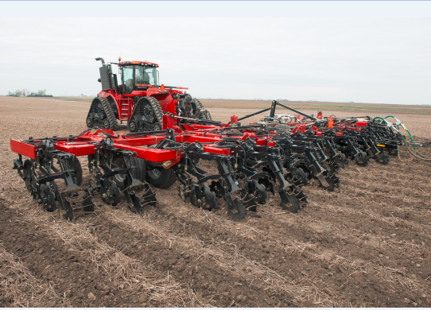

**Caption:** The Nutri-Tiller 955 from Case IH is a one-pass seedbed solution that helps producers more effectively manage time, resources and inputs.

Click [[HERE](http://www.caseih.com/northamerica/en-us/service/newsroom/multimedia)] to download a hi-res file.

**Redesigned row unit, unmatched accuracy**

Through the principles of Case IH Agronomic Design™, the Nutri-Tiller 955 includes features that deliver strip-till success:

* **Improved mounting design** of the new High-clearance Shank™ for Strip-Till (HCS ST) helps ensure the knife and shank stay aligned for uniform operating depth, precise nutrient placement and pass-to-pass accuracy.
* **New row cleaner** effectively moves high levels of crop residue between the rows without gouging or riding on top of residue. Two down-pressure spring settings let producers match aggressiveness to field conditions.
* **The Berm Build’r™** creates a uniform, properly shaped and sized berm. Concave 18-inch notched sealing disks include holes on the disk face to help reduce soil buildup.
* **Rolling-basket options for the** **Berm Condition’r™** — a concave design for fall use and a flat-bar design for spring use — help put the final touches on the raised strip and finalize the seedbed.

“Minimal shank deflection with the 1¼-inch by 2-inch edge-bent shank, combined with the mount’s holding force, helps the HCS ST maintain a constant depth for uniform berms and accurate nutrient placement,” said Long.

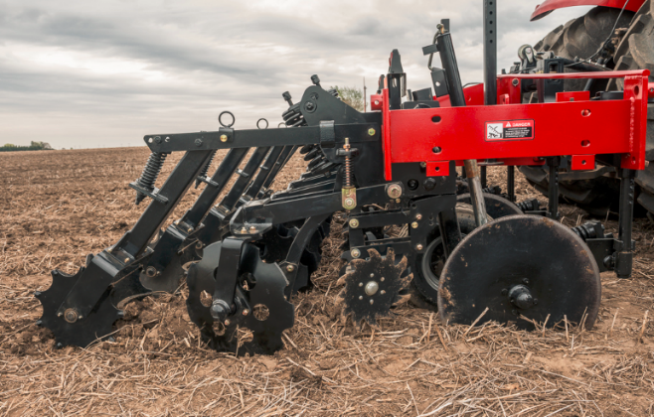

**Caption:** A new row unit on the Nutri-Tiller 955 from Case IH creates an ideal planting zone that helps crops get off to a fast, uniform start.

Click [[HERE](http://www.caseih.com/northamerica/en-us/service/newsroom/multimedia)] to download a hi-res file.

**Durable, yet flexible, frame**

The Nutri-Tiller 955 is available in working widths from 20 feet to 60 feet (8, 12, 16 and 24 rows). Built with Case IH exclusive welded bridge construction, the 30- and 40-foot models flex in three sections, while the 60-foot model flexes in five sections. Other features include single-point depth control for quick in-field adjustments, easy folding for narrow transport, new LED lighting for improved safety, and new VF radial tire options for better flotation and reduced compaction.

**Fertilizer efficiency**

With an optional air package, available on the 30- and 40-foot units, the Nutri-Tiller arrives field-ready to pair with the Case IH Precision Air™ 5 series air cart. This option allows deep banding of up to two dry fertilizers, plus anhydrous ammonia. A new modular metering system offers industry-leading precision and accuracy, and seamlessly integrates with Case IH Advanced Farming Systems for variable-rate application of up to three fertilizer products.

Visit your local Case IH dealer or [caseih.com](http://www.caseih.com/northamerica/en-us/service/newsroom/multimedia) for more information.

Case IH is a global leader in agricultural equipment, committed to collaborating with its customers to develop the most powerful, productive, reliable equipment — designed to meet today’s agricultural challenges. With headquarters in the United States, Case IH has a network of dealers and distributors that operates in over 160 countries. Case IH provides agricultural equipment systems, flexible financial service offerings and parts and service support for professional farmers and commercial operators through a dedicated network of professional dealers and distributors. Productivity-enhancing products include tractors; combines and harvesters; hay and forage equipment; tillage tools; planting and seeding systems; sprayers and applicators; site-specific farming tools; and utility vehicles. Case IH is a brand of CNH Industrial N.V. (NYSE: CNHI / MI: CNHI).

###